**Factors Affecting Childhood Development and the Current State in North Western Melbourne**

Author: Anthony Duong

In a systematic review of literature regarding determinants of early childhood development, the authors identified that along with physical development, family environment is extremely important to childhood development, namely the parent’s capacity to raise their children both financially and emotionally.1 This report will investigate the effects of these factors on early childhood development in North Western Melbourne and identify what areas may need extra support to promote healthier development.

**Prenatal Factors**

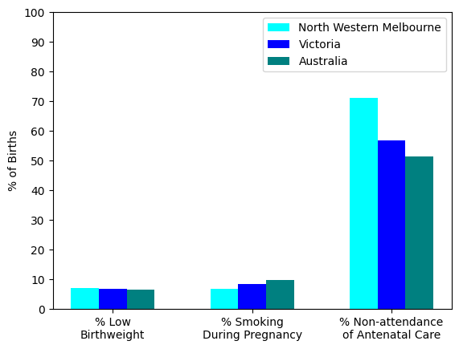

**Figure 1: Mother and Child Data for North Western Melbourne, Victoria and Australia**

A child’s development begins long before birth and relies heavily on the mother’s health and behaviour during the antenatal period. 2 Expectant mothers must refrain from smoking and highly recommended to attend antenatal care to ensure healthy delivery of their child. In the North Western Melbourne Region PHN, the rate of low birthweight babies is in line with the state and national rate of around 6.6% and the percentage of women smoking during pregnancy is lower at 6.8% compared to 8-9% of the state and national rate. However, this region sees that 71% of women are not attending antenatal care within the first 10 weeks of pregnancy, which is significantly higher than 51-56% at the state and national level.

Looking at each LGA within North Western Melbourne individually, it can be seen that they are all at or above the average rate for non-attendance of antenatal care in Victoria. It can be seen that in particular, Wyndham, Melton and Brimbank have the highest non-attendance at over 80%. This could mean that any health promotion regarding the importance of antenatal care has failed to reach a majority of the population, this may be due to the high percentage of migrant population, with around 50% born overseas and 50-70% of the population having both parents being born overseas and health promotion therefore may need to be altered to appeal to the cultural majority of the population.3-5

The lack of antenatal care is a risk factor in many pregnancy related diseases, including low birth weight, infection during perinatal and postnatal periods and even maternal or child mortality, which can be easily prevented with proper antenatal care, making it essential to incentivise and promote attending care to improve childhood development.2

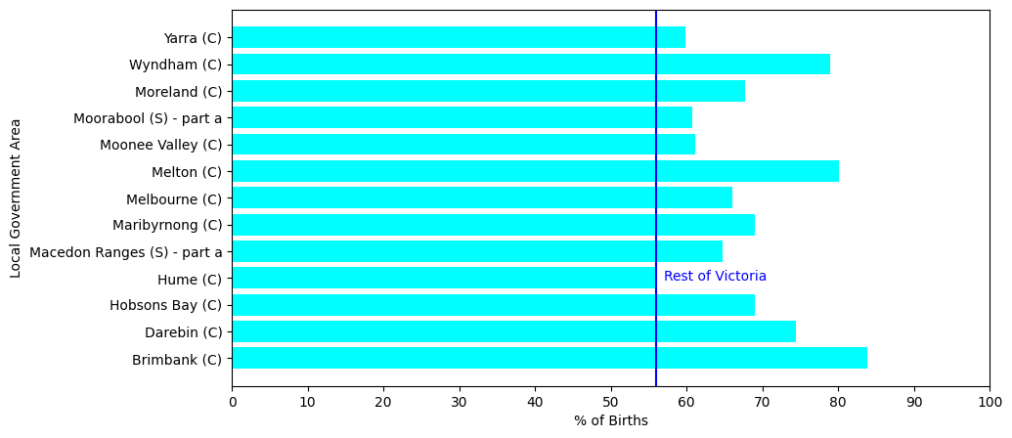

**Figure 2: Non-attendance of Antenatal Care Within First 10 weeks for LGAs North Western Melbourne**

Blue line depicts non-attendance for Victoria

**Household and Family Factors**

The systematic review identified household and family environments are important to a child’s development. Poor infrastructure and quality of life at home can lead to poor nutrition as well as poor social and intellectual development. 1 Studies show that a child’s home is where they learn and develop the most skills and when the home is overcrowded, this process can be disrupted, negatively impacting their mental health and development.6

In Victoria 8% of families who have children under 15 years old and 14% of single parent families are living in crowded homes. In North Western Melbourne, there is 11% and 19% respectively, meaning there is a significant portion of the population who may be at risk of stunted development.

This can be due to 17% of families being single parent families, and 64% of them do not own their home, with a significant portion of them living in public housing or social housing and the quality of infrastructure of many of these apartments have not seen significant updates, which is in line with a survey answered by public housing residents in 2020, 20% of which do not think their home is adequately sized for them.7

In addition to being crowded, the families living in these places could have financial instability, which may further affect development if there is a low ability to invest in the child’s development and on their health.

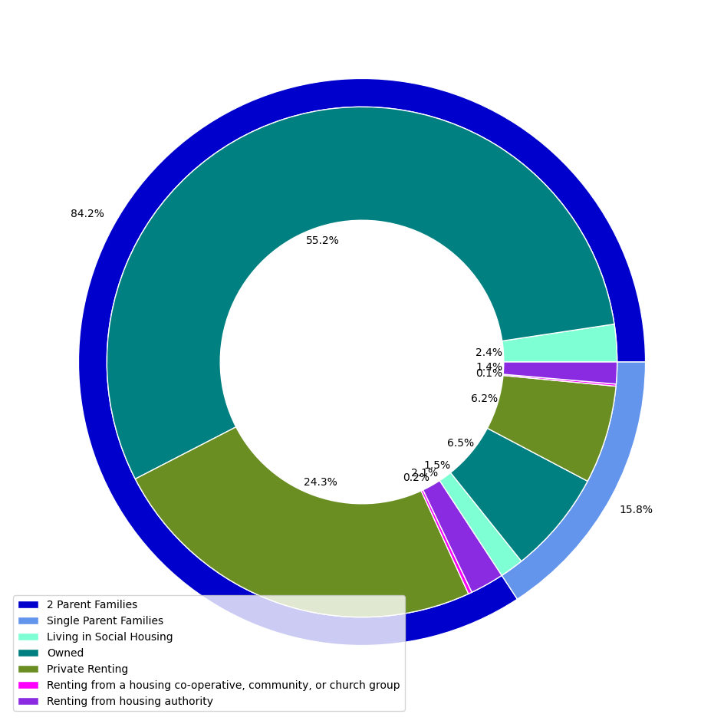

**Figure 3: Pie Chart of Housing for Families with Children by Family Type**

This financial instability can result from the rate of joblessness, where families are dependent on Centrelink income support to be able to raise a family. Again, this may mean that the parents cannot afford to invest in child development beyond schooling and necessities, potentially leading to lower cognition, social ability and poorer overall health. These factors can compound and affect their education quality and in turn their future earnings when they become adults.8 From the PHIDU data in figure 4, it can be seen that there is a high variance between LGAs with Hume and Brimbank having the highest rate of jobless families, while Macedon ranges and Moonee Valley have about half their rate.

The reason for the low employment rate is unclear and more data is needed before a proposal on a solution can be made. However, the effects of the low employment and thus lack of stable income can be mitigated through community programs such as community health clinics for regular health check-ups and community centres for social development. The continual investment in these programs may support healthy child development and be more economical in preventing disease rather than attempting to cure later in life and can potentially lighten the burden of growing up in a disadvantaged environment.9

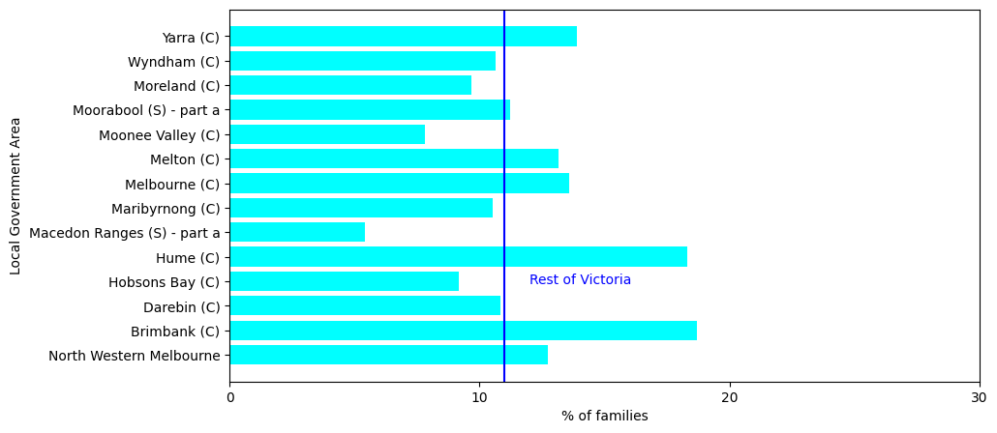

**Figure 4: Jobless Families as a Percentage of Total Families with Children**

Blue line depicts percentage of jobless families for Victoria

**AEDC Survey and Where North Western Melbourne Stands**

The AEDC is a survey conducted in the first year of school to assess their development in both physical and psychological domains. Most of the children within North Western Melbourne are on track with 21.8% children developmentally vulnerable in one or more domains and 11.1% in two or more domains, with the social and communication domains being the highest categories of development vulnerability.

b

a

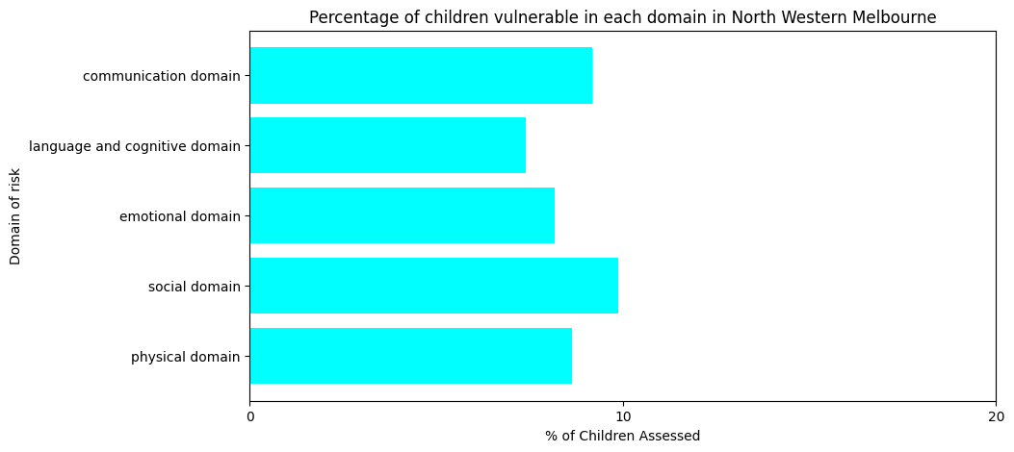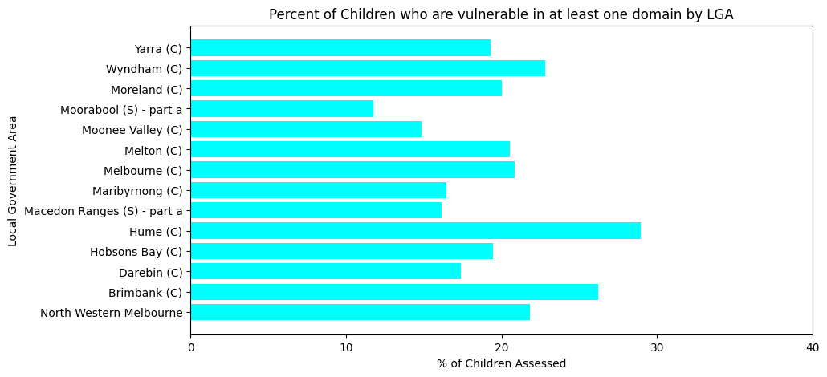

**Figure 5: AEDC Data Summarised by LGA and North Western Melbourne Overall**

Figure 5b once again shows that Brimbank, Wyndham and Hume have the most children with at least one at risk category and these areas should be targeted for improvement.

**Conclusions**

Overall, the percentage of vulnerable children in North Western Melbourne do not differ greatly to the state or national rate and most of the children are on track.

More regular tracking of development would allow better tracking of developmental vulnerabilities as the child grows, allowing for more points of intervention to steer the child back on track to healthy development.

Childhood development is not a simple equation, but many studies have a identified a few key factors that may affect it, starting in the antenatal period before the child is even born. The mother must ensure that she takes adequate care during pregnancy and attend antenatal care sessions to lower the risk of stunted development. Non- attendance of antenatal care puts the child at risk of physical growth abnormalities and in the worst cases maternal or child mortality. This is a major area of concern in North Western Melbourne as around 70% of mothers do not attend antennal care, especially in Wyndham, Melton and Brimbank LGAs. More effort and resources need to be allocated in properly promoting and incentivising attending these care sessions to ensure healthy development of the child postnatally.

A child’s environment also plays a major role in their development, especially the adequacy of space and privacy within their own home. 11% of children are living in crowded dwellings and that rate goes up to 19% in single parent households, which can not only disrupt their ability to learn skills at home, but also put them at risk of other health issues stemming from high density living. This is compounded by the high jobless family rate in the community, which can further lead to cognitive and social issues later in life. The AEDC data also suggests that social and communication skills are potentially high risk domains within this PHN, suggesting that community based activities to promote social interaction between children in each LGA may alleviate some strain in this domain.

Overall, on the measures reported, North Western Melbourne is on par or slightly disadvantaged when compared to the rest of Victoria, with the major concern lying in the high non-attendance rate to antenatal care. North Western Melbourne should continue to invest in community programs and public housing projects to provide both an adequate home environment and build a foundation for children to have the best chance of healthy development. Investing in preventative health not only lowers the risk of developing chronic illnesses later in life, such as cardiovascular disease and obesity, but also potentially lowers the cost of healthcare for individuals and governments as there is less of a need to invest in treatment of those diseases.10-11 Therefore, it would be in the best economic and health interest to invest in preventative care for youths, to both lighten the load on the healthcare system and promote healthier living in their futures.

**References**

1. Rosa CQ, Silveira DS, Costa JS. Factors associated with lack of prenatal care in a large municipality. Revista de Saúde Pública. 2014;48(6):977–84. doi:10.1590/s0034-8910.2014048005283
2. Likhar A, Baghel P, Patil M. Early childhood development and social determinants. Cureus [Internet]. 2022 Sept 23 [cited 2024 Jan 12]; Available from: https://www.ncbi.nlm.nih.gov/pmc/articles/PMC9596089/ doi:10.7759/cureus.29500
3. Australia [Internet]. [cited 2024 Jan 12]. Available from: <https://www.abs.gov.au/census/find-census-data/quickstats/2021/LGA21180>
4. Australia [Internet]. [cited 2024 Jan 12]. Available from: https://www.abs.gov.au/census/find-census-data/quickstats/2021/ LGA24650
5. Australia [Internet]. [cited 2024 Jan 12]. Available from: <https://www.abs.gov.au/census/find-census-data/quickstats/2021/LGA27260>
6. Solari CD, Mare RD. Housing crowding effects on children’s wellbeing. Social Science Research. 2011 Oct 15;41(2):464–76. doi:10.1016/j.ssresearch.2011.09.012
7. 1. Resident surveys [Internet]. 2023 [cited 2024 Jan 13]. Available from: <https://www.housing.vic.gov.au/resident-surveys>
8. 1. Berger LM, Paxson C, Waldfogel J. Income and child development. Children and Youth Services Review. 2009 Sept 1;31(9):978–89. doi:10.1016/j.childyouth.2009.04.013
9. 1. Brinkman SA, Hasan A, Jung H, Kinnell A, Pradhan M. The impact of expanding access to early childhood education services in rural Indonesia. Journal of Labor Economics. 2016 Dec 16;35(S1). doi:10.1086/691278
10. Missed prevention opportunities - the healthcare imperative - NCBI ... [Internet]. [cited 2024 Jan 13]. Available from: <https://www.ncbi.nlm.nih.gov/books/NBK53914/>
11. Wang F, Wang J-D. Investing preventive care and economic development in ageing societies: Empirical evidences from OECD countries. Health Economics Review. 2021;11(1). doi:10.1186/s13561-021-00321-3

**Additional Information**

Data source: <https://phidu.torrens.edu.au/current/data/shatopics/child_youth/phidu_child_and_youth_data_phn_lga_aust.xls>

The data was analysed using python 3.10 and Jyupter notebook. Data visualisation was done in python 3.10 utilising the matplotlib library.

The code is public domain and available on GitHub via the following link: <https://github.com/bananabite/NWMPHN_report>